**Experiment No. 2**

**Title: Implementation of List and Tuple Data Structures**

**Batch: B1 Roll No: 1914078 Experiment No.:2**

### Aim: To implement a program for list and tuple methods and functions.

**Resources needed:** Python IDE

### Theory:

### List is an ordered sequence of items. It is one of the most used datatype in Python and is very flexible. All the items in a list do not need to be of the same type.

### Declaring a list is pretty straight forward. Items separated by commas are enclosed within brackets [ ].

### a = []

### a = [1, 2.2, 'python']

### We can use the slicing operator [ ] to extract an item or a range of items from a list. Index starts form 0 in Python. Negative indexing is also allowed.

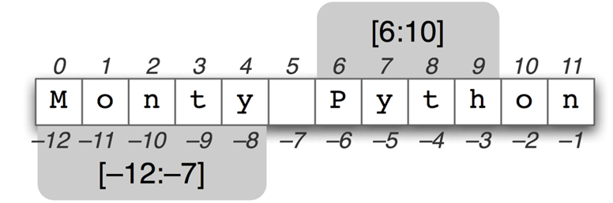

Lists are mutable, meaning, value of elements of a list can be altered.

**list functions:**

len(): length of list.

sorted(): sorts list in asceding order

list(): converts into list

[**Python List Methods**](https://www.programiz.com/python-programming/methods/list)**:**

Append()- Adds item at the end of the list

[extend()](https://www.programiz.com/python-programming/methods/list/extend) - Add all elements of a list to the another list

[insert()](https://www.programiz.com/python-programming/methods/list/insert) - Insert an item at the defined index

[remove()](https://www.programiz.com/python-programming/methods/list/remove) - Removes an item from the list

[pop()](https://www.programiz.com/python-programming/methods/list/pop) - Removes and returns an element at the given index

clear() - Removes all items from the list

[index()](https://www.programiz.com/python-programming/methods/list/index) - Returns the index of the first matched item

[count()](https://www.programiz.com/python-programming/methods/list/count) - Returns the count of number of items passed as an argument

[sort()](https://www.programiz.com/python-programming/methods/list/sort) - Sort items in a list in ascending order

[reverse() – R everse](https://www.programiz.com/python-programming/methods/list/reverse) the order of items in the list

**Tuples in python:**

Tuple is an ordered sequence of items same as list. It is defined within parentheses () where items are separated by commas. E.g. t = (5,'program', 1+3j). Creating tuple with single element using a=(1,)

The only difference is that tuples are immutable. Tuples once created cannot be modified. Tuples are used to write-protect data and are usually faster than list as it cannot change dynamically. For eg. Lat long data.

We can use the slicing operator [] to extract items but we cannot change its value

**Tuple functions:**

len(): length of typle.

max():maximum values from numeric or string tuple

min(): minimum values from numeric or string tuple

sum(): sum of numeric tuple

sorted(): sorts tuple in asceding order

tuple(): converts list into tuple

**Tuple Methods:**

index(obj): returns first index of obj in tuple

count(): total number of times obj occurs in tuple

### Activities:

### 1. Write a program to accept a list of numbers and then perform following on it.

* Remove duplicates
* Create 2 separate lists of even and odd
* Find the count of numbers in each list
* Merge the even and odd list in ascending order
* Swap the first and last element
* Insert & delete at particular index.
* Using List comprehension create a list of fibinocci series upto n

**2. Find the sum of the populations of the New England states. Printout how many there are. Use a basic loop design pattern.**

newEngland = (("Massachusetts",6692824),("Connecticut",3596080), ("Maine",1328302),("New Hampshire",1323459), ("Rhode Island",1051511),("Vermont",626630))

### Result: (script and output)

lis = list(map(int,input().split(",")))

# Removing duplicates

lis = list(set(lis))

print(lis)

# Odd

odd = [x for x in lis if x%2==1]

print("Odd elements : ",odd)

print("Length of odd list: ",len(odd))

# Even

even = [x for x in lis if x%2==0]

print("Even elements : ",even)

print("Length of even list: ",len(even))

# Merge and sort

merge=[]

merge.extend(odd)

merge.extend(even)

print("Merged unsorted list: ",merge)

merge.sort()

print("Merged sorted list: ",merge)

# Swapping first and last element

x = lis[-1]

lis[-1] = lis[0]

lis[0] = x

print("Swapped list: ",lis)

# Insert and delete

pos = int(input("Enter a position to insert: "))

val = int(input("Enter the value to be inserted: "))

lis.insert(pos,val)

print(lis)

pos = int(input("Enter a position to delete: "))

lis = lis[:pos] + lis[pos+1:]

print(lis)

### Output:-

### 

Q2)

# Fibonacci

n = int(input())

lis=[1,1]

[lis.append(lis[k-1]+lis[k-2]) for k in range(2,n)]

print(lis)

### 

### Q3)

newEngland = (("Massachusetts",6692824),("Connecticut",3596080),("Maine",1328302),("New Hampshire",1323459),("Rhode Island",1051511),("Vermont",626630))

count = 0

total = 0

for (x,y) in newEngland:

  total+=y

  count+=1

print("Total population:",total)

print("Total number of New England states:",count)

### 

### Outcomes: Use of Basic Data Structures in Python

### Questions:

### 1. Explain concept of deep copy and shallow copy.

A shallow copy constructs a new compound object and then inserts references into it to the objects found in the original. A deep copy constructs a new compound object and then, recursively, inserts copies into it of the objects found in the original.

deepcopy() creates new object and does real copying of original object to new one. ... deepcopy() copies original object recursively, while . copy() create a reference object to first-level data of original object.

**Conclusion:** We implemented a program for list and tuple methods and functions.

**References:**

* 1. **Reema Thareja , “Python Programming: Using Problem Solving Approach”, Oxford University Press, First Edition 2017, India**
  2. **Sheetal Taneja and Naveen Kumar,” Python Programing: A Modular Approach”, Pearson India, Second Edition 2018, India**